**Load the Data into an RDS Instance**

**Dataset-1-Tools:**

<https://s3.amazonaws.com/amazon-reviews-pds/tsv/amazon_reviews_us_Tools_v1_00.tsv.gz>

**review_id_table_tools**

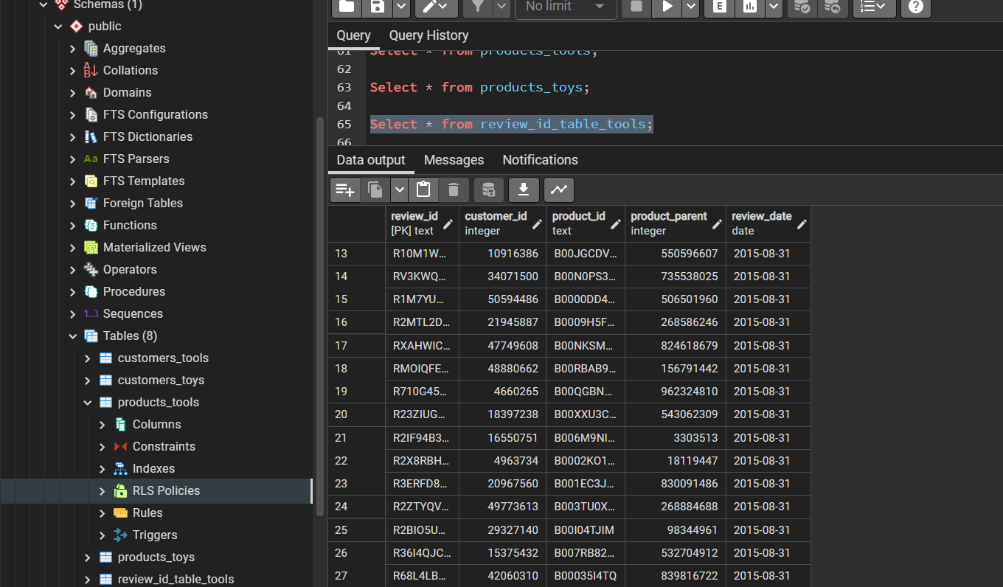

**products_tools**

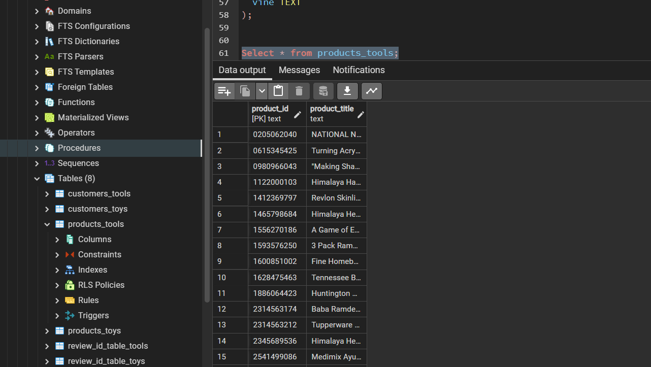

**customers_tools**

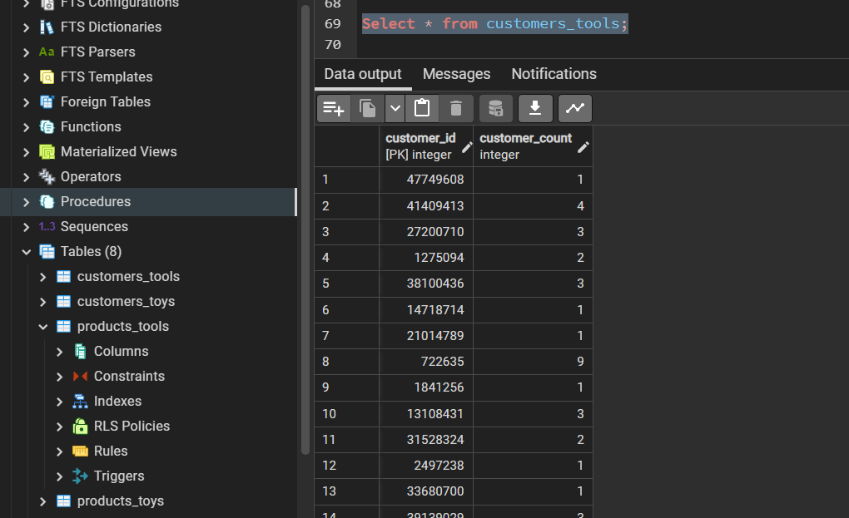

**vine_table_tools**

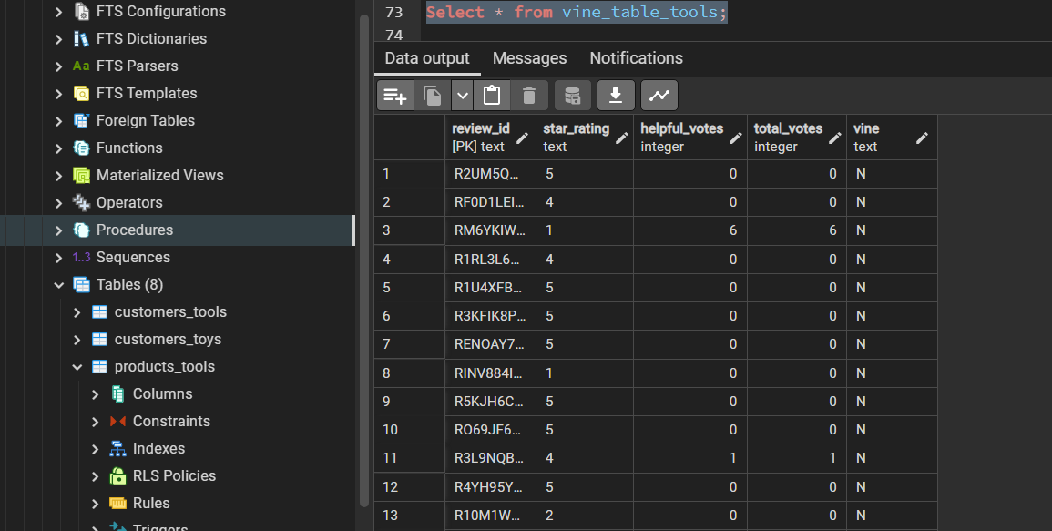

**Dataset-2-Toys:**

<https://s3.amazonaws.com/amazon-reviews-pds/tsv/amazon_reviews_us_Toys_v1_00.tsv.gz>

**review_id_table_toys**

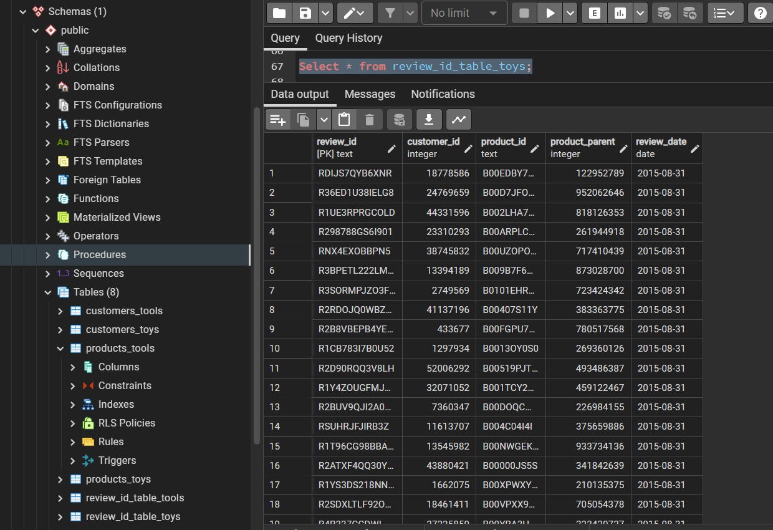

**products_toys**

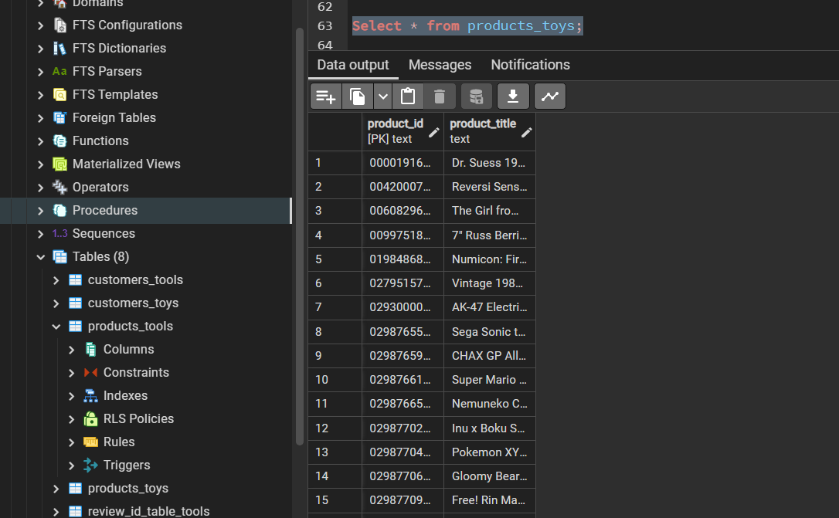

**customers_toys**

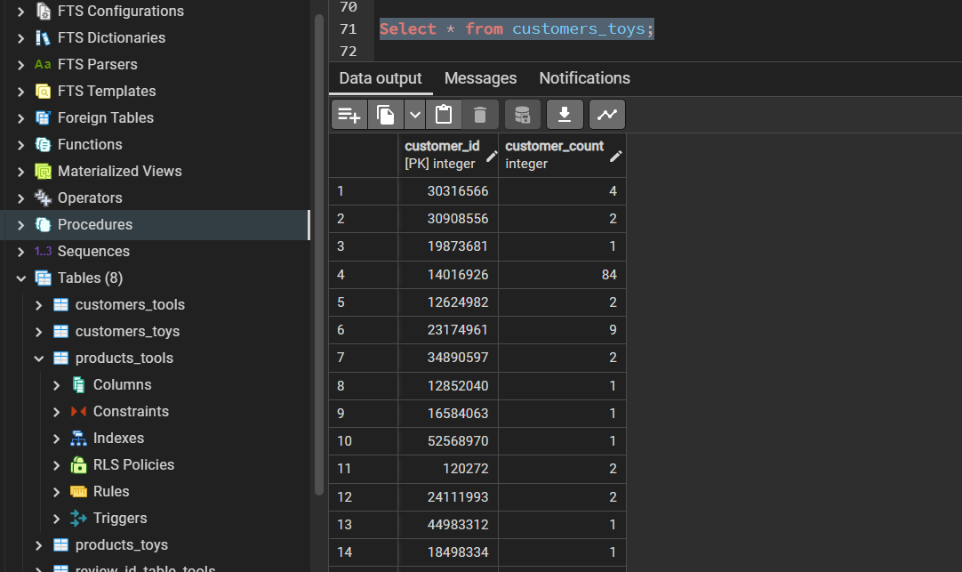

**vine_table_toys**

